**Design Patterns and Principles**

**Exercise 1: Implementing the Singleton Pattern**

**Logger.java**

**package** SingletonPatternExample;

**public** **class** Logger {

//step 1: Private static instance

**private** **static** Logger *instance*;

//step 2: Private Constructor

**private** Logger() {

System.***out***.println("Logger instance created...");

}

//step 3: Method to get the instance

**public** **static** Logger getInstance() {

**if**(*instance*==**null**) {

*instance* = **new** Logger();

}

**return** *instance*;

}

**public** **void** logTesting(String text) {

System.***out***.println("INFO :"+text);

}

}

**LoggerTest.java:**

**package** SingletonPatternExample;

**public** **class** LoggerTest {

**public** **static** **void** main(String[] args) {

Logger logger1 = Logger.*getInstance*();

logger1.logTesting("This is the first test message");

Logger logger2 = Logger.*getInstance*();

logger2.logTesting("This is second test message");

**if**(logger1 == logger2) {

System.***out***.println("Both Logger instances are the same");

}

**else** {

System.***out***.println("Logger instances are different");

}

}

}

**Output:**

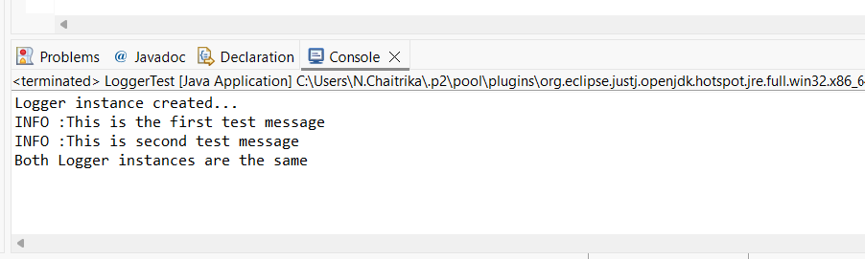

**Exercise 2: Implementing the Factory Method Pattern**

**Document.java:**

**package** FactoryMethodPatternExample;

**public** **interface** Document {

**void** open();

}

**WordDocument.java:**

**package** FactoryMethodPatternExample;

**public** **class** WordDocument **implements** Document{

**public** **void** open() {

System.***out***.println("Opening Word Document...");

}

}

**PdfDocument.java:**

**package** FactoryMethodPatternExample;

**public** **class** PdfDocument **implements** Document{

**public** **void** open() {

System.***out***.println("Opening PDF Document...");

}

}

**ExcelDocument.java:**

**package** FactoryMethodPatternExample;

**public** **class** ExcelDocument **implements** Document{

**public** **void** open() {

System.***out***.println("Opening Excel Document...");

}

}

**DocumentFactory.java:**

**package** FactoryMethodPatternExample;

**public** **abstract** **class** DocumentFactory {

**public** **abstract** Document createDocument();

}

**WordFactory.java:**

**package** FactoryMethodPatternExample;

**public** **class** WordFactory **extends** DocumentFactory{

@Override

**public** Document createDocument() {

**return** **new** WordDocument();

}

}

**PdfFactory.java:**

**package** FactoryMethodPatternExample;

**public** **class** PdfFactory **extends** DocumentFactory{

@Override

**public** Document createDocument() {

**return** **new** PdfDocument();

}

}

**ExcelFactory.java:**

**package** FactoryMethodPatternExample;

**public** **class** ExcelFactory **extends** DocumentFactory{

@Override

**public** Document createDocument() {

**return** **new** ExcelDocument();

}

}

**Output:**

